Requirements Specification for a digital card-gaming device

Specification

System Description
This specification describes and defines the basic requirements for a wearable digital card-gaming device. The device will house 1 or more RFID readers that would take data from placed RFID cards and use them in a game of the user’s choosing. The user would be able to wirelessly communicate with other players in possession of the device for multiplayer mode.

Specification of External Environment
The device is to be operated in an indoor/outdoor environment with relative humidity consistent with desert and tropical environments. It must be durable enough to withstand various types of users, especially small children. The unit is to be portable and battery operated.

System Input and Output Specification

System Inputs
The system shall support the measurement of the following kinds of signals:
- Frequency in the standard 13.56 MHz range for close range RFID signals

The system will also accept user input from a keypad that will determine what mode the system is in.

If the system is in multiplayer mode, it must receive game data from another device and modify the user’s game based on that data.

System Outputs
The system shall display information about the current game state and the reading from the RFID signal on an LCD display

When the system is in multiplayer mode, data must be sent wirelessly to another device.

User Interface
The user shall be able to select the following using buttons and switches on the front panel of the instrument
Mode:
Single Player
Multiplayer
Card Building
Card Reader:

Power ON/OFF
Reset
The measurement results shall be presented on an LCD display. Such a display shall be readable from several angles.
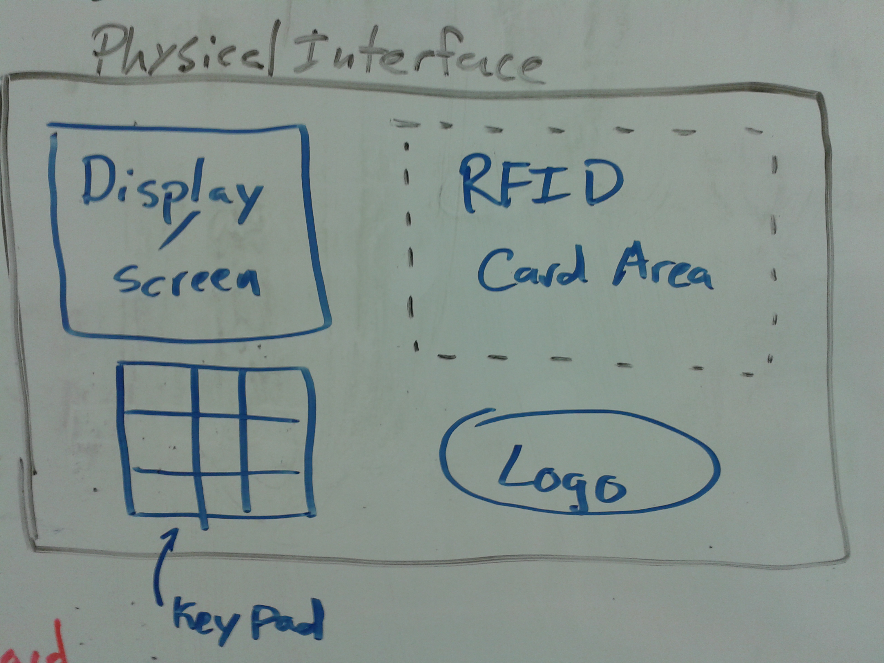
Simple drawing of the front panel

System Functional Specification

A user will be provided with a deck of RFID cards that contain data about whatever game the user wants to play. These cards would be used in the RFID reading device that would be worn by the user on their arm. First, the user must choose using the keypad what game mode they would like to play: singleplayer, multiplayer, or card building. In all three modes, the user will be instructed by the programmed game to place a card in the RFID reading area to interact with the game and control events. In multiplayer mode the user would have to find the other user they would like to play with and connect to their game using the wireless features of the system. In card building mode, the user would be able to enter data via the keypad to program their own data onto whichever RFID card they choose.

Operating Specifications
The system shall operate in a standard commercial or household environment
Temperature Range 0-60C (32-140F)
Humidity 30-60% non-condensing
Power 5 VDC

Reliability and Safety Specification
The counter shall comply with the following safety standards
UL: None
FCC Part 15, subparts A, C for Low Power Devices
ISO 18000-3 (RFID), 18092(EMCA-340 ), 21481(ECMA-352), 14443

The MTBF will be a minimum of 1,000 hours

